

INFORMACIÓN DE TOURS

TOURS INFORMATION


ADVENTURE ACTIVITIES

Mambo Combo
Make the most of your limited vacation time!! Combine the exciting Adventures of Canyoneering and Rafting on the Beautiful Balsa River for a Full Day of Pure adrenaline. This unique tour includes a delicious typicallunch, snack, transportation and guide.
Departure Time: 7:00 am - Duration 8 Hrs


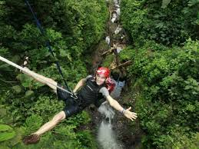

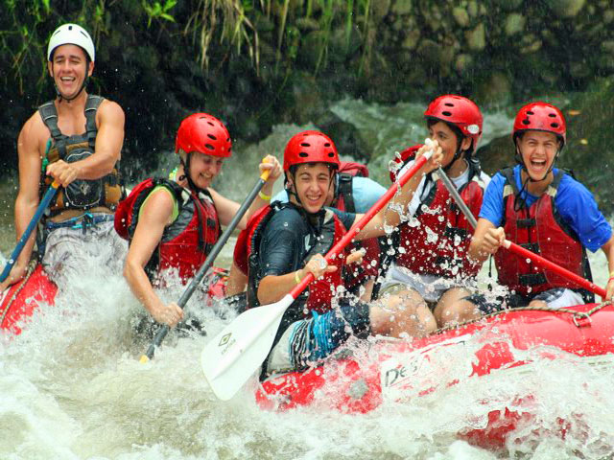
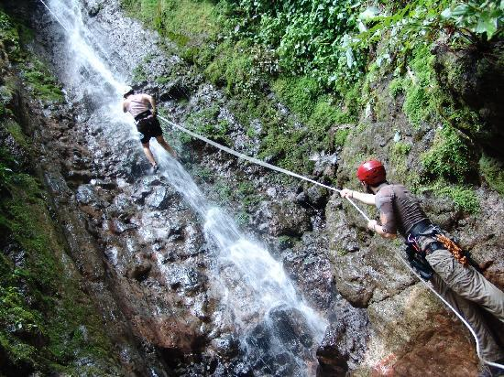

Rafting Class II-III Balsa River
Half day rafting class II-III closer to the Arenal Volcano!! Challenge yourself as you paddle through fun and safe rolling rapids. Hopefully you´ll get to see lots of wildlife like monkeys, sloths and tropical birds. This tour includes transportation, snack, typical lunch and guide.
Departure Time: 10:30 am - Duration 5 Hrs
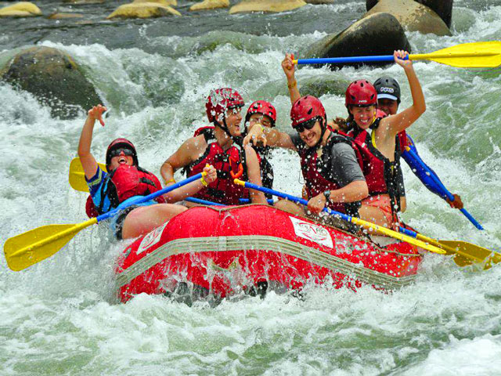

Rafting Class III-IV
This tour offers some of Costa Rica’s best white water with big waves, technical rapids and continuous whitewater. Could be Toro or Sarapiqui River depending the water level. This tour includes transportation, snack, typical lunch and guide.
Departure Time: 8:00 am - Duration 8 Hrs

Canyoneering
Take a walk combined with down-climb falls in an isolated jungle canyon in Arenal. This adventure is perfect for those looking to experience the thrill of descending breath taking waterfalls in a deep, jungle canyon while taking in the beauty of the rainforest! This tour includes transportation, typical lunch and guide.
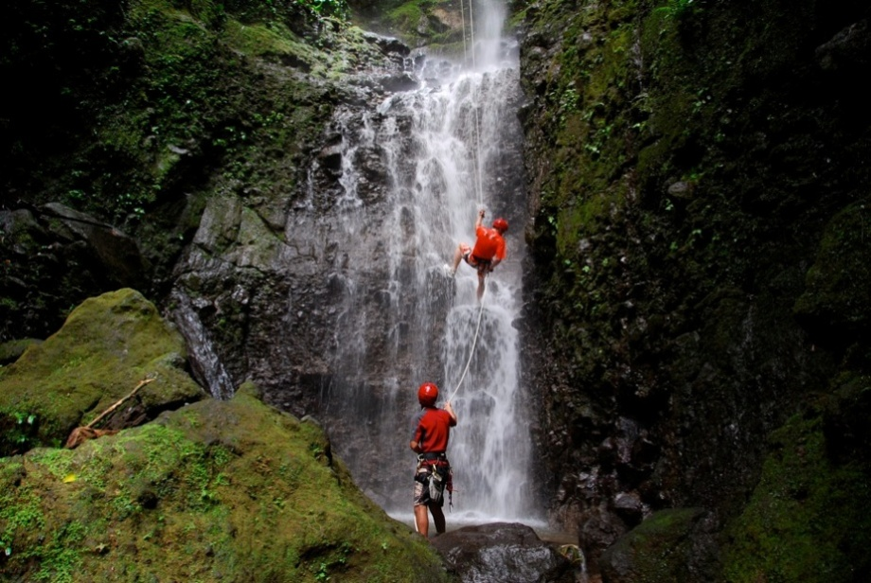
Departure Times: 7:10 am, 9:40 am & 12:40 pm - Duration 4 Hrs

Arenal Vista Canopy Tour
A healthy release of adrenaline and an incredible immersion in nature with moving panoramic views. It will offer you the opportunity to observe wildlife in its natural habitat.10 cable from 80 to 750 meters length. This tour includes transportation and guide.
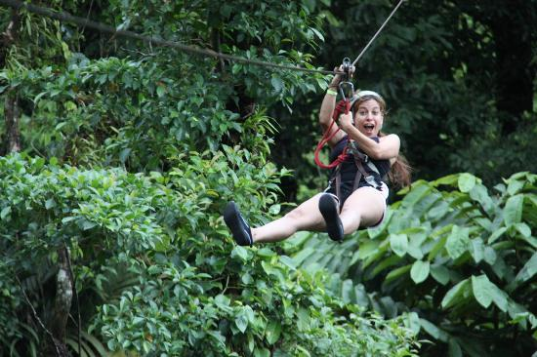
Departure Times: 7:45 am, 10:15 am, 12:45 pm & 2:45 pm - Duration 2.5 Hrs


Sky Tram & Sky Trek
For maximum adrenaline rush. Ride the cable car up the heights and enjoy the zip lines with fantastic views of the Arenal Volcano and Lake. The tour includes 8 cross-sectional cables that together have a total length of 1.7 miles with distances from 100 to 2460 feet, and with a maximum height of 660 feet.
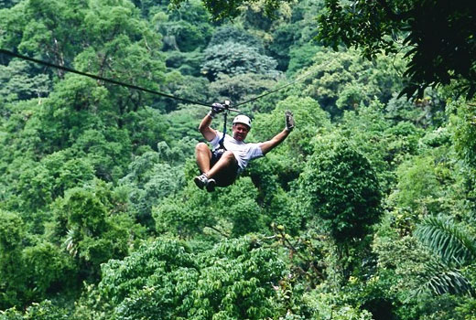
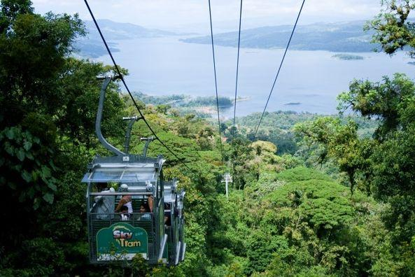
Departure Times: 8:20 am, 9:50 am, 10:50 am, 1:20 pm, 2:20 pm & 3:15 pm - Duration 3.5

Venado Caves
Trek through underground waterfalls, prehistoric fossils and exotic cave formations. There are not lights or walkways, so you will feel as if you are the first person to discover them. There is no turning back now. It´s a little difficult to walk up the river, but that´s just part of the adventure. Includes transportation, guide and beverage.
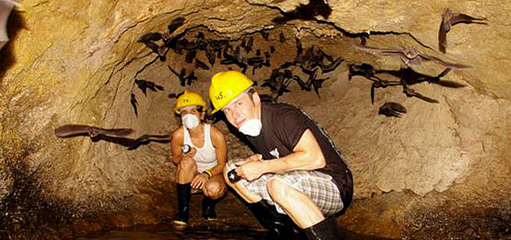
Departure Times: 7:00 am & 1:05 pm - Duration 4 Hrs


ATV´s around the Volcano
Experience the challenge of driving an ATV on the slopes of the volcano on trails through the forest. Includes transportation, guide and beverage.
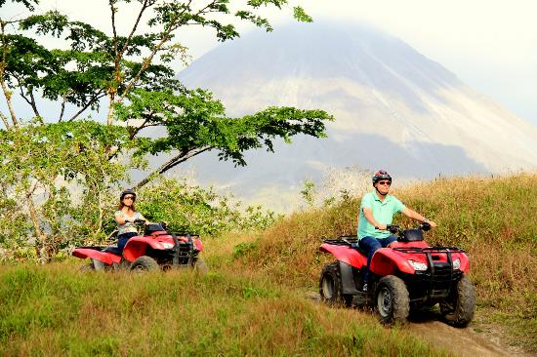
Departure times: 7:50 am, 11:20 am & 2:50 pm - Duration 3 Hrs

ATV´s to a Private Farm
Adventure route to a private farm and visit to the Arenal River by ATV. Includes transportation, guide and lunch.
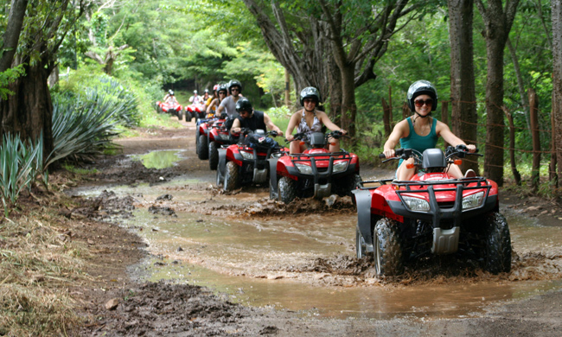
Departure times: 7:15 am, 10:45 am & 2:15 pm - Duration 3 Hrs

Horseback to La Fortuna Waterfall
This is a great combination of horseback riding and Hiking to La Fortuna Waterfall. The ride is through green lands surrounded by tropical forest, during the way you will appreciate beautiful rivers, the company of a lot of birds. Include transportation, guide and entrance ticket.
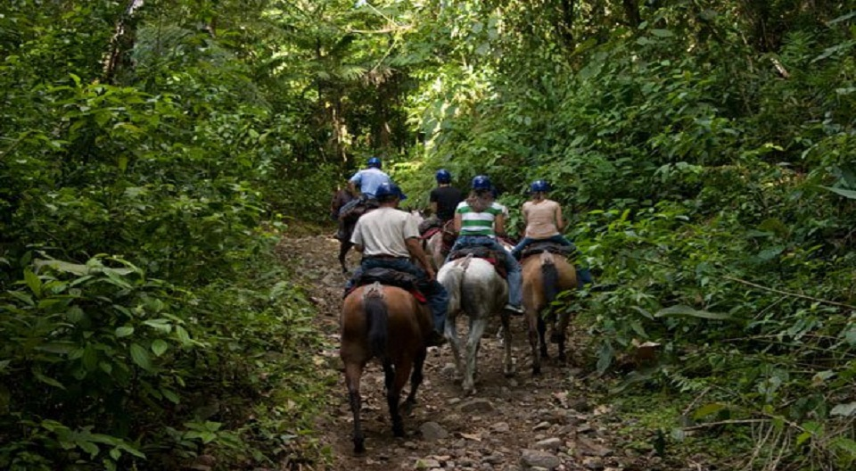
Departure Times: 8:20 am & 1:10 pm - Duration 3.5 Hrs

Horseback around the Arenal Volcano
For Horse-Lovers and those who wish enjoy the most fascinating sceneries in the Arenal Conservation Area. This is your chance to see one of the most spectacular views of the Arenal Volcan. Include transportation, guide and entrance ticket.
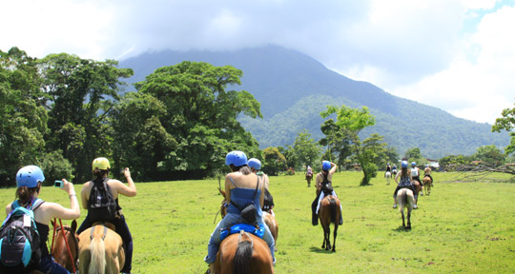
Departure Times: 7:45 am, 11:15 am & 2:45 pm - Duration 3 Hrs

Mountain Bike Ride
Take a moderate level guided bike ride near to the base of Arenal Volcano and Lake. We´ll be biking on a quiet lane surrounded by dense forest and perfect views of the Arenal Volcano. Include equipment, transportation, snack and guide.
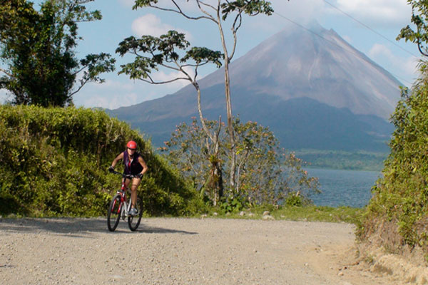
Departure Times: 8:05 am & 1:45 pm - Duration 4 Hr

Stand Up paddling Arenal Lake
Stand up on a large, wide, super buoyant board similar to a surfboard and use a long paddle to move yourself along. You'll feel like you're walking in water! Include transportation, guide and snacks.
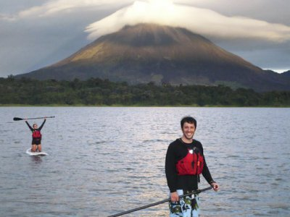
Departure times: 8:05 am & 1:40 pm - Duration 4 Hrs


NATURE LOVERS

Volcano Hike
Hike along the trails of the National Park, we will enter into the tropical forest and areas which were once devastated by the fury of the Volcano. Our naturalist Guide will provide important information about the Volcano and the area. Include transportation, guide and park tickets.
Departure Times: 7:45 am & 3:20 pm - Duration 3 Hrs

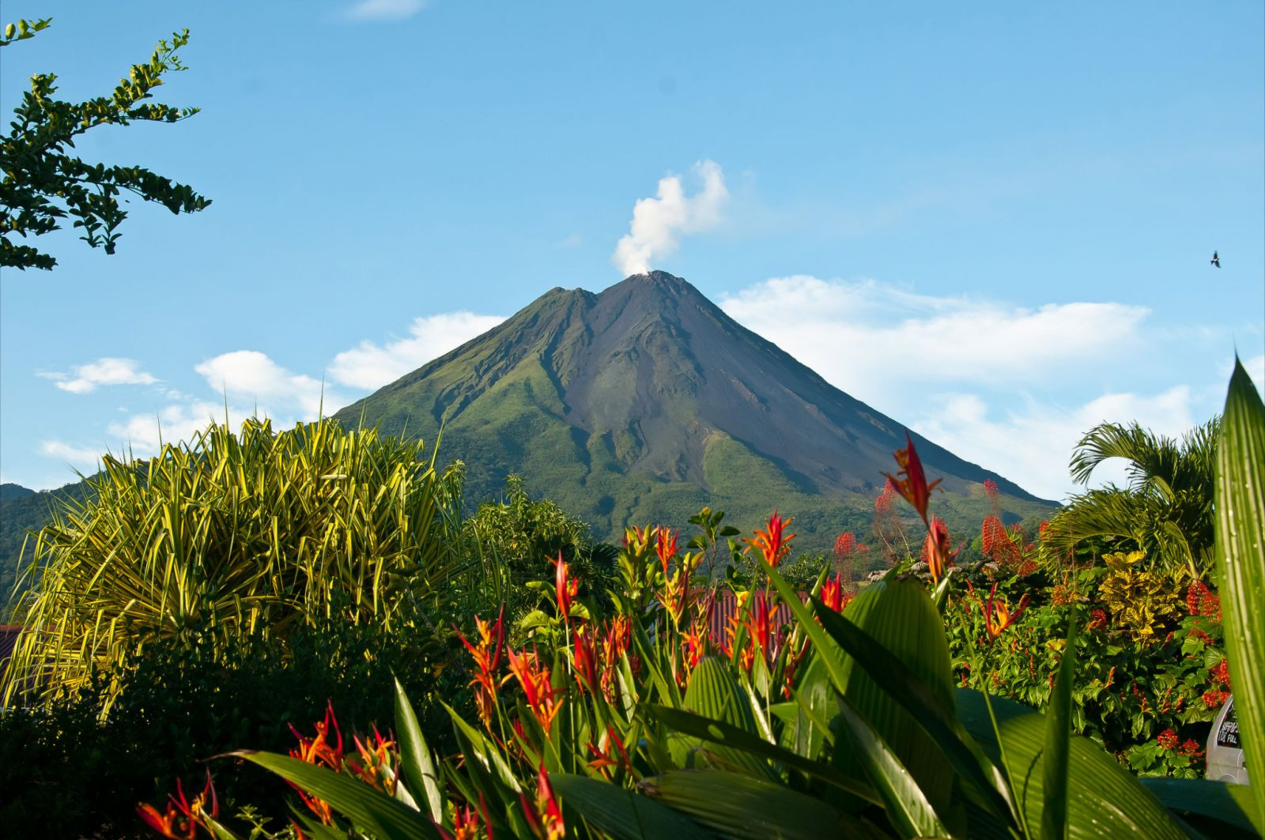

Rio Celeste Hike
Located at the Tenorio Volcano, this river is unique in the country. We will take a hike to ¨Los Teñideros¨ where the river takes on a different chemical reaction and it changes color. Include transportation, guide, park tickets and lunch.
Departure Time: 7:00 am - Duration 8 Hrs

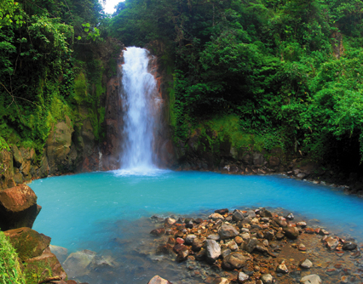

Cerro Chato Hike
For people wishing a long hike and with good physical condition for go uphill. This option will take you all the way up to the top of Cerro Chato. From there you will have great views of the Arenal Volcano and San Carlos plains. Include transportation, guide, box lunch and park ticket.
Departure Time: 7:45 am - Duration 7 Hrs
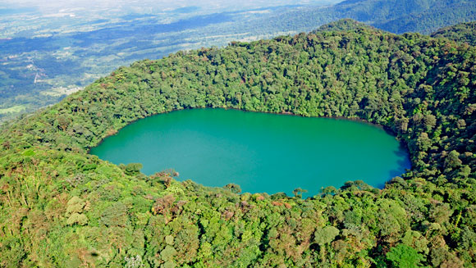

Hanging Bridges
Trail of 3.1 kilometers you will go through very impressive bridges, some of them suspended over the forest, from these bridges you will have a great views of the canopy of the rain forest. Include transportation, guide and park tickets.
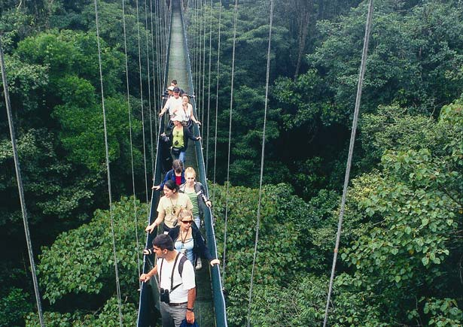
Departure times: 7:45 am & 1:00 pm - Duration 3 Hrs

Nigth Walk
This is the opportunity to see the other face of the forest and nature by night in Arenal Natura Ecological Park. Frog Watching and nocturnal animals

Departure time 5 30 pm-duration 2.5 hours

Bird Watching
864 are the species of birds that can be seen all over the country and more than 340 can be found around the Arenal Volcano Area. That's why this is for bird watching lovers. Include transportation, guide and snacks.
Departure Times: 5:30 am - Duration 4 Hrs
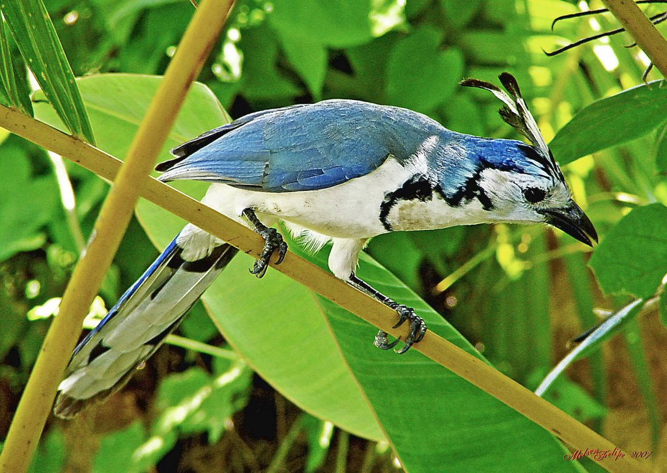

Unique Caño Negro
Enjoy the unsurpassed natural beauty of Caño Negro in a peaceful covered boat. Observe waterfowl and a variety of Flora and Fauna. For Nature Lovers. Include transportation, guide and lunch.
Departure Time: 7:00 am - Duration 8 Hrs
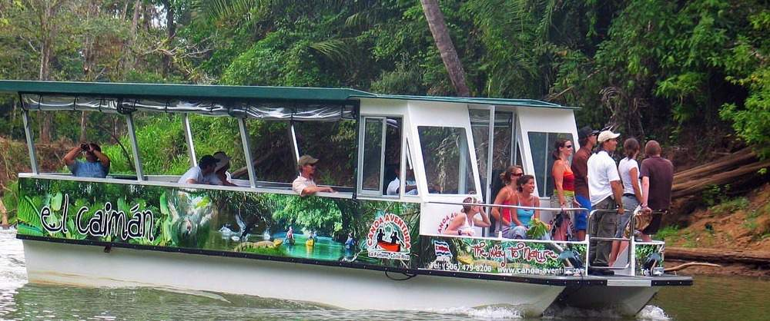

Safari Float by Raft
Excellent opportunity to observe local flora and fauna in the calm waters of Peñas Blancas river. Include transportation and guide.
Departure Times: 7:00 am & 1:05 pm - Duration 4 Hrs
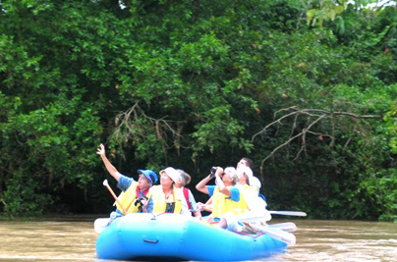


Kayak on the Arenal Lake
Discover incredible sceneries and views of the lake, its coast, forest and of course the majestic Arenal Volcano. Include transportation, guide and fruits.
Departure times: 8:05 am & 1:40 pm - Duration 4 Hrs
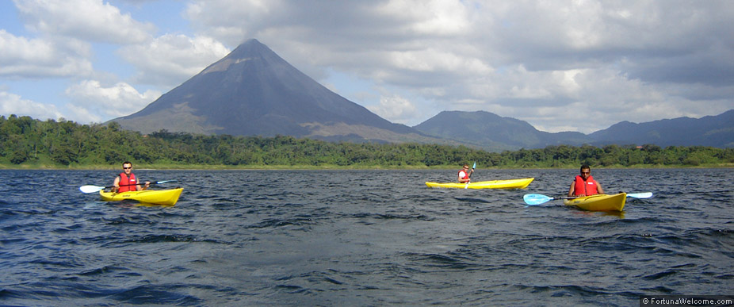

Cultour Casona Rio Fortuna
Share our culture, tradition and style of daily life in Costa Rica on a unique tour that combines the beauty of nature and encounters with the local population. Include transportation, guide and lunch.
Departure Times: 8:00 am, 11:30 am & 2:30 pm - Duration 5 Hrs
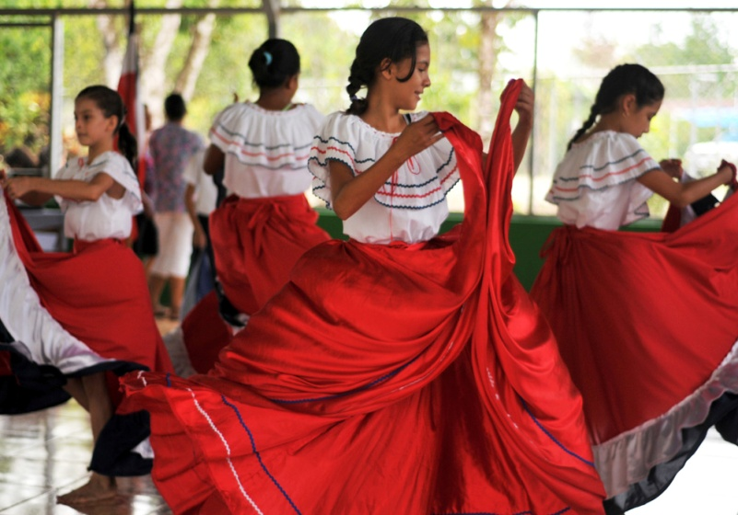
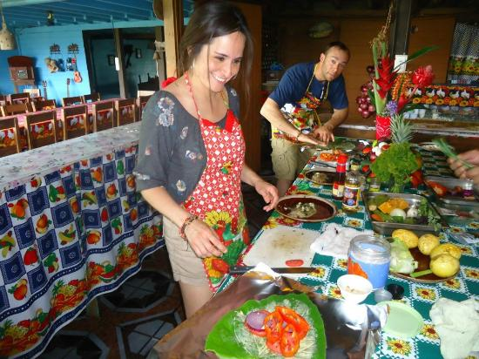

COMBINATION TOURS

La Fortuna One Day
First we will visit the Hanging Bridges, around 11:30 am will stop at "La Fortuna Waterfall", 1:30 pm Typical lunch, later the Volcano Hike in the National Park and our last stop will be at the hot springs, where will also have dinner.
Departure time: 7:45 am - Full Day Activity
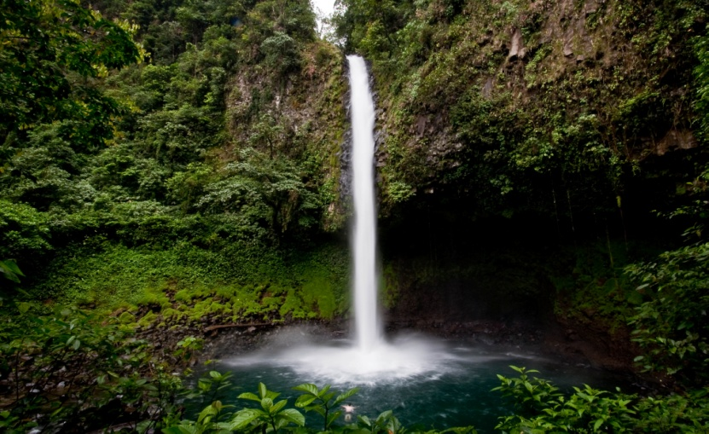
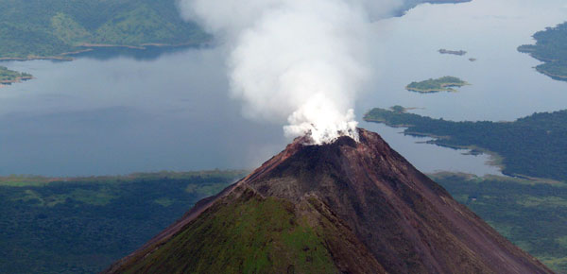

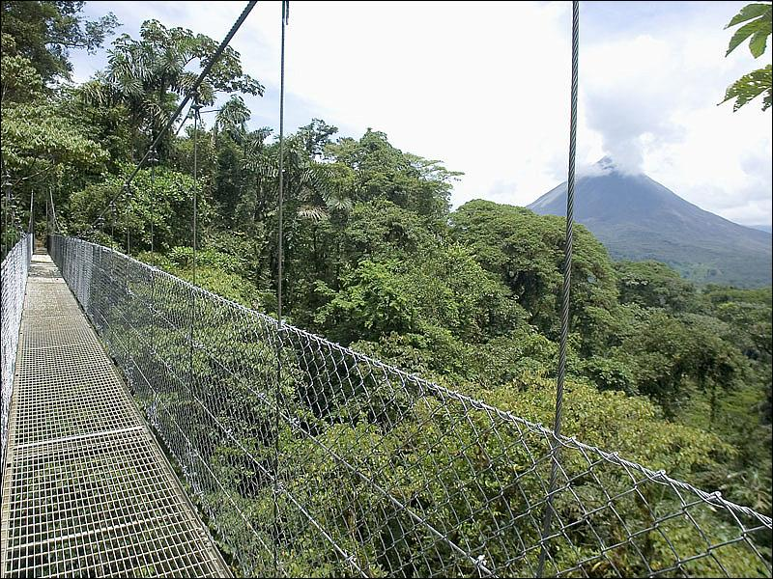

Volcano Hike, hot springs and one meal
During the tour you can see a variety of flora and fauna characteristic of the area, while walking along the lava paths of 1992, then relax in the hot springs of your choice with a meal included.
Departure times: 7:45 am & 3:20 pm - Duration 6 hrs
